

UNDERGRADUATE PROJECT REPORT

|  |  |
| --- | --- |
| **Project Title:** | **Game development** |
| **Surname:** | **Wang** |
| **First Name:** | **zijia** |
| **Student Number:** | **201918020222** |
| **Supervisor Name:** | **James Blouin** |
| **Module Code:** | **CHC 6096** |
| **Module Name:** | **Project** |
| **Date Submitted:** | **May 5, 2023** |

# **Declaration**

Here, students would sign a statement indicating that they adhered to appropriate academic conduct in carrying out their final project.

# **Acknowledgment**

Here, students are given the opportunity to thank those who have provided you with assistance and support.

# **Table of Contents**

**Declaration** i

**Acknowledgment** ii

**Table of Contents** iii

**Abstract** iv

**Abbreviations** vi

**Glossary** vii

**Chapter 1 Introduction** 1

**1.1** **Background** 1

**1.2** **Aim** 1

**1.3** **Objectives** 2

**1.4** **Project Overview** 3

**1.4.1** **Scope** 3

**1.4.2** **Audience** 4

**Chapter 2 Background Review** 5

**2.1** **Competitive analysis** 5

**2.1.1** **Gameplay mechanism** 5

**2.1.2** **Art style** 6

**2.1.3** **User experience** 6

**2.1.4** **Marketing strategy** 7

**Chapter 3 Methodology** 7

**3.1** **Approach** 7

**3.1.1** **Agile development** 7

**3.1.2** **User-centered design** 8

**3.1.3** **Prototyping** 9

**3.2** **Technology** 9

**3.2.1** **tools** 10

**3.2.2** **Testing and Evaluation** 10

**3.3** **Project Version Management** 11

**Chapter 4 Results** 12

**Chapter 5 Professional Issues** 12

**5.1** **Project Management** 12

**5.1.1** **Activities** 12

**5.1.2** **Schedule** 13

**5.1.3** **Project Data Management** 13

**5.1.4** **Project Deliverables** 13

**5.2** **Risk Analysis** 13

**5.2.1** **Risk analysis of game fun** 13

**5.2.2** **Game engine risk analysis** 13

**5.2.3** **Risk Analysis of game level Design** 14

**5.2.4** **Risk Analysis of game character design** 14

**5.2.5** **Network security risk analysis** 14

**5.2.6** **Risk analysis of infringement of others' intellectual property rights** 15

**5.3** **Professional Issues** 15

**Chapter 6 Conclusion** 16

**References** 16

**6.1** **Formatting Requirements** 17

**6.2** **Written Presentation** 18

**Appendices** 18

# **Abstract**

Up to 250 words, concise outline of background, aims, results, and achievements.

***Keywords: This is part of the “Abstract” section. Students are to provide at least 3 keywords that best describe their project topic. Do not list more than 8 keywords.***

# **Abbreviations**

This section should have the definition of any abbreviations used in the report

# **Glossary**

This section should have the definition of all the keywords you stated in the “Abstract” section. You can also define other relevant keywords. Particularly, if your final project report includes rare, unfamiliar, specialized, or made-up words or terms, the glossary serves as a dictionary for the reader to reference throughout their reading of the project report. (Note: this section should only contain definitions for specific terms in the project report. It does NOT function as an ordinary dictionary. Hence, common words related to the Computer Science and Software Engineering disciplines should NOT be included in this list.)

# **Introduction**

*This is an update of the Introduction from your previous reports. Students are to also incorporate the feedback from their supervisor. Also, include subsequent ideas and research that you have discovered.*

## **Background**

This project is a 2D horizontal mystery puzzle game. It is a local suspense puzzle game with Chinese theme. Players will control the characters (story participants and witnesses) and interact with the scene props in the game. As the story progresses, they will solve the interlocking puzzles and find out the truth of the events.

The main characteristic of the decryption game is to solve the puzzles in the game and decipher code, to promote the development of the game story.

Decryption games usually require players to think and reason about scenes, props, words and other information in the game, and successfully decipher puzzles in the game by collecting and analyzing clues or information provided in the game.

In general, decryption games test players' intellectual and psychological qualities. While challenging players, they also train players' thinking and logical abilities.

In the game industry, there are already many games related to the horror and suspense genres, such as Silent Hill, The Evil Within, and The Forest. Some of these games have great graphics and great modeling, some have an exciting story pace, some have great game style, and most importantly, the atmospheres are so good that the players feel a sense of tension and pressure throughout the process. This has helped horror puzzle games gain popularity and support in the industry.

## **Aim**

The overall goal of your project should be stated here. It is recommended that each project should have a single aim.

The aim of this project was to design and implement a challenging 2d horizontal puzzle game with unique mechanics that would engage the player and provide a novel gameplay experience. The game will be developed using Unity2D game development engine and C# programming language. At the same time, the game mechanism and design elements of exploration and decryption will also increase the playability and interest of the game.

The main contributions of this study include:

1. Designed and implemented a fun, innovative, and challenging 2D horizontal puzzle game.

2. This paper analyzes the mechanism and design elements of the game, including game difficulty, game level design, game props design, etc., and provides a reference for game design and research.

3. The evaluation also tested the game's playability, fun and user experience, and provided references and suggestions for improvements and upgrades.

Through the exploration and practice of this research, developers can have an in-depth understanding of the mechanics and design elements of games, improve the level and ability of game design and development, and provide better and more interesting game experience for game players

## **Objectives**

Students are to state the several tasks/steps that would help them to accomplish the overall aim/goal of their project.

Ob1. Analyze the game mechanism, design elements, experience and other characteristics of existing 2D horizontal decryption games.

Ob2. Analyze and define the target user, and then design the game to meet the needs and preferences of the target user.

Ob3. Complete the game design document, which will include the game background, mechanism introduction, level design and user interface.

Ob4. Develop a game prototype in the game development engine to demonstrate the core gameplay and innovative design of the game.

Ob5. Complete the image and animation design of the game, enhance the visual appeal of the game, and improve the user experience.

Ob6. Complete sound effects and game music, enhance the audio-visual effects of the game, create a stronger game atmosphere, let players feel the emotions that the development wants to convey, and better understand the story and background of the game.

Ob7. Optimize the game, from the perspective of optimizing performance, user experience, and resource size, optimize the completed game to improve game quality and user experience.

## **Project Overview**

(NB: Most students are working either on a software development-based project or a machine learning/deep learning-based project. Hence, in section 1.4, students must adopt the appropriate theme/content depending on their project topic.)

### **Scope**

The scope of a software development project should answer the questions: what will the software do? How will the software work? The scope for a machine learning/deep learning-based project should focus on answering the questions: what is the purpose of the study? How significant is the study?

This project is developing a 2D horizontal decryption rpg game, which will be developed using the Unity 2D engine. In the game, the player will play a role. By manipulating the character to walk around the map, interact with the scene, obtain key props and game information, drive the game story forward. The game will have a unique information acquisition mechanism, providing players with a brand new gaming experience through innovative mechanisms. The game's user interface will be designed to be clean and intuitive, natural graphics and animations will enhance the user experience, and the game's sound effects and music will complement the emotions and themes expressed by the game.

The game will be developed using the Unity 2D engine, which will provide basic design tools and functions. After developers are familiar with its basic functions, Hongpu can quickly create 2D games.

### **Audience**

The audience for a software development project should focus on who is the software for? The audience for a machine learning/deep learning-based project should focus on who will benefit from the findings.

This project will divide the audience with reference to the PEGI rating system (Pan European Game Information). Age ratings are systems used to ensure that entertainment content, such as games, but also films, tv shows or mobile apps, is clearly labelled with a minimum age recommendation based on the content they have. These age ratings provide guidance to consumers, parents in particular, to help them decide whether or not to buy a particular product for a child. While most games are suitable for players of all ages, others are only suitable for older children and young teenagers. A specific portion of games on the market contains content that is only appropriate for an adult audience (PEGI, 2023).

This item may involve depictions of violence to the same stage as in reality, and may also involve the use of tobacco, alcohol, or illegal drugs. According to the PEGI classification, this item is classified as PEGI 16.

Definition of PEGI16: This rating is applied once the depiction of violence (or sexual activity) reaches a stage that looks the same as would be expected in real life. The use of bad language in games with a PEGI 16 rating can be more extreme, while the use of Tobacco, alcohol or illegal drugs can also be presented. (PEGI, 2023).



Label of PEGI16

https://pegi.info/what-do-the-labels-mean

https://pegi.info/sites/default/files/inline-images/age-16-black.jpg

At the same time, similar violent descriptions and pictures will appear in the project. According to the definition of PEGI: The game contains depictions of violence. In games rated PEGI 7 this can only be non-realistic or non-detailed violence. Games rated PEGI 12 can include violence in a fantasy environment or non-realistic violence towards human-like characters, whereas games rated PEGI 16 or 18 have increasingly more realistic-looking violence.​ The project will also add the PEGI content descriptors.



THE PEGI CONTENT DESCRIPTORS

https://pegi.info/what-do-the-labels-mean

https://pegi.info/sites/default/files/inline-images/violence-black-EN.jpg

# **Background Review**

This chapter is an update of the Background Review from your previous reports, using the feedback you received from your supervisor. Compare existing approaches and include a themed literature review, with a critical appraisal of the sources. Provide appropriate and sufficient references. Also include *the feedback you received from your supervisor. You can add any additional key sources that you have discovered.*

Students doing software development-based projects can write their background review by providing a **summary of existing approaches (e.g., competitive analysis, if appropriate),** and others doing research-oriented projects (machine learning & deep learning projects) can write their background review by stating **a summary of related literature (e.g., annotated bibliography, or initial literature review, with a brief summary of sources).**

**Annotated Bibliography aids as in doing a good literature review. It is not the literature review. However, your final background review must be paragraphs with appropriate citations. Whenever appropriate, a table can be adopted.**

## **Competitive analysis**

This part will compare and analyze the popular horror decryption games on the market, and draw conclusions by analyzing their gameplay mechanism, user experience, art style, marketing strategy, etc.

### **Gameplay mechanism**

In the field of horror decryption game industry, the success of Silent Hill is well deserved. One of Silent Hill's ([SILENT HILL PORTAL SITE (konami.com)](https://www.konami.com/games/silenthill/us/en/))

signature gameplay mechanics is its use of psychological horror elements, such as twisted environments and disturbing sound effects. Other survival horror games, such as Outlast and Resident Evil, use similar mechanics to create fear and tension during gameplay. Silent Hill is known for its more subtle approach to psychological horror, which sets it apart from other games. This project is a suspense puzzle game. When the plot is ups and downs, it will use tight rhythm music as BGM to create an atmosphere. As a 2D horizontal game, it will use more text descriptions and more detailed descriptions, such as the psychological activities of the characters, more delicate dialogues, more rigorous plots, etc., complement the lack of three-dimensionality in the picture.

### **Art style**

The art style of this project will be based on the social background of China in the 2010s, through the investigation of the social atmosphere, public security, people's livelihood, economy, etc. at that time, the dialogue between the game characters, the interactive items and scenes of the game will be full of the spirit of the times. In terms of color usage, the color matching of the game will be influenced by the fashion trends and popular culture at that time, using a darker color scheme, reflecting the heaviness of the game plot and the challenging social background. The game's architectural and environmental design will also be influenced by the Chinese urban landscape of the 2010s, which may contain elements of traditional Chinese architecture, as well as contemporary design elements reflecting the rapid development and modernization of Chinese cities during this period. These design elements allow the game to create a uniquely immersive game world, rich in cultural references and historical significance. It helps to immerse gamers of this game more deeply in the game world.

### **User experience**

This work will be characterized by immersive storytelling and perfect character images. In other horror games such as "Layers of Fear", the story and character development will also be given priority. However, this work will use a more complex and ambiguous narrative, In the process of restoring the truth of the incident, players need to piece together the details of the story by themselves. Using complex and ambiguous narratives can add extra depth to a game's story, as players are left to piece together the details of the story themselves. This can create a sense of mystery and intrigue, keeping players immersed and motivated to discover the truth behind the events of the game. To ensure a good user experience, the game will balance narrative complexity with clear and intuitive game mechanics, and the game will use visual cues, such as environmental cues and character dialogue, to provide hints to players as they explore the game world and uncover the story and guidance, in addition, puzzles and interactive objects can help reinforce the narrative, providing players with a sense of progression and accomplishment.

### **Marketing strategy**

In the early promotion and marketing, "Silent Hill" mainly relied on the word-of-mouth and evaluation accumulated by Western players. This project uses social media strategies to promote the game and attract target users. Determine what social media to share game development and news on based on which platforms the game's target audience is most active on. The second is to consider contacting content creators and game authors in the relevant game communities to increase the exposure and awareness of the game.

# **Methodology**

## **Approach**

The approach for a software development project should focus on the description of the software development methodology being used for the project. For example, the software development model, requirement-gathering methods, etc.

The approach for a machine learning/deep learning-based project should focus on describing the core machine learning model to be employed. Describe the mathematical basis, the algorithm details, and the optimization strategy, if applicable. Also, describe the datasets and data processing techniques to be used where relevant.

### **Agile development**

The game will be developed using agile development, an iterative, flexible approach to software development that emphasizes the ability to collaborate between teams of developers and to respond to changes in development content or goals. This kind of development is ideal for game development, as agile development allows for very frequent testing and iteration of the game's mechanics and design elements.

Iterative development: In iterative development, this project will develop the game narrative in an iterative and flexible development manner. This means that during the entire development process, developers will test and improve different story content (such as scripts for different chapters, outlines, etc.) This helps ensure that the game's narrative is more engaging for players, and helps developers avoid potential roadblocks and problems during development.

Kanban agile development framework

In this project, the game will be developed using the Kanban agile development framework. Using a Kanban framework that emphasizes visual management, continuous flow, and limiting work-in-progress consists of a Kanban board that shows work items (e.g., user stories, bugs, etc.) and their status (e.g., to-do, in-progress, completed). The framework focuses on limiting work in progress, management processes, and continuous improvement processes. This project will use PingCode ([https://pingcode.com](https://pingcode.com/)) as a research and development management tool to manage the agile development of this project.

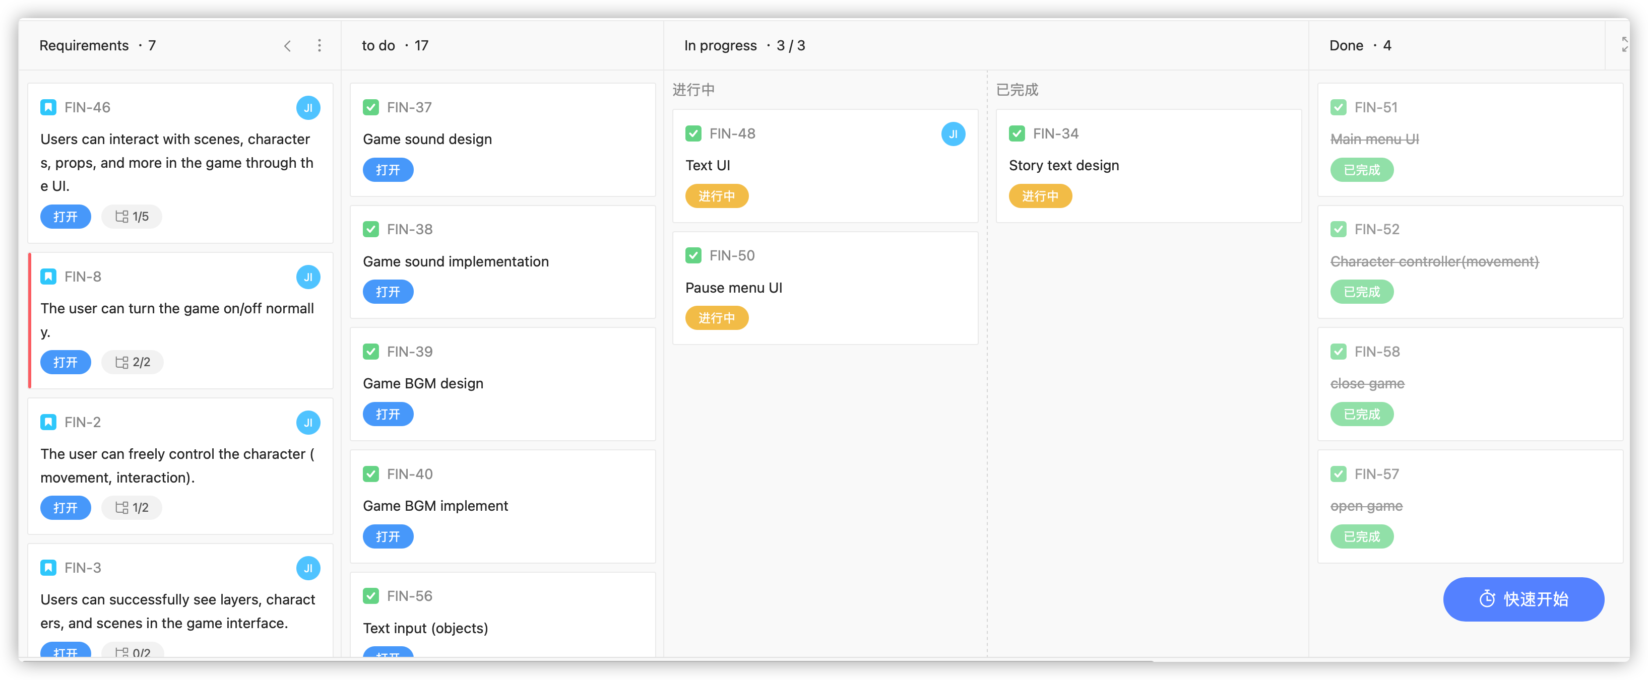

Example of Kanban

The following is the process of using the Kanban development framework for this project：

1.Create a kanban board: Contains four columns: "Requirements", "To do", "In progress" and "Done".

2.Write user stories after collecting user needs, and formulate task cards based on user stories. Break down user stories into smaller tasks or work items and place them in task progress bars.

3.Add task cards to the "To Do" column.

4.Prioritize the backlog based on the importance and value of the feature or user story to the game. Use colors to distinguish priorities, red, orange, yellow, blue, and green correspond to priorities from high to low.

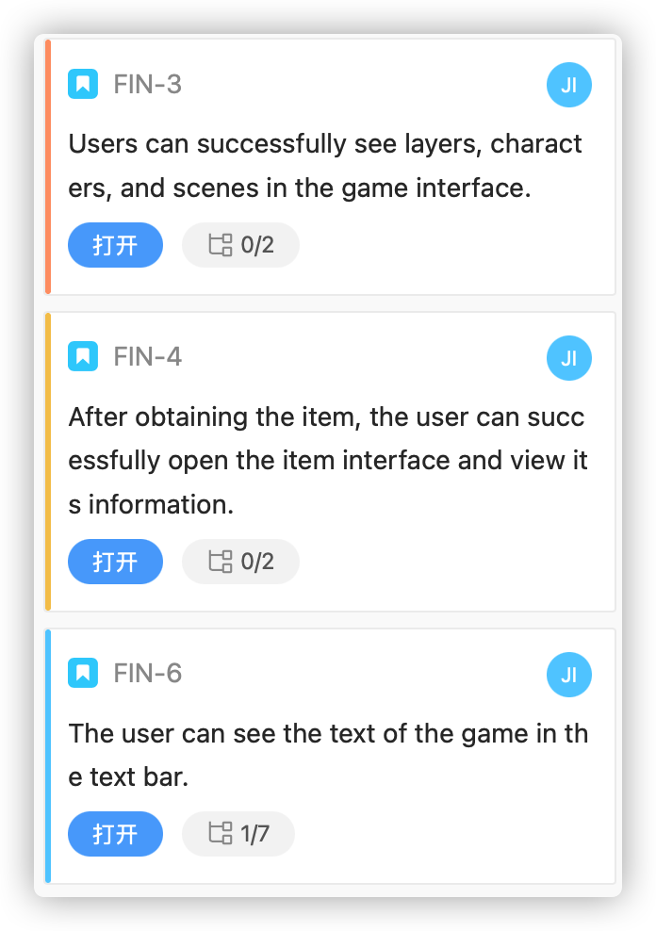

User stories that are prioritized by color

5.Start the sprint: Select the highest priority card from the "To Do" column and move it to the "In Progress" column to start the sprint.

6.Continuous Delivery: As a feature or user story is completed, the corresponding card is moved to the "done" column. This provides continuous delivery of working software and allows teams to get feedback early in the development process.

### **User-centered design**

In user-centered design, the most important thing is to focus on understanding the needs and preferences of the product's end users. This design helps ensure that the game is engaging and fun for the intended audience.

User search: In order to understand the needs and preferences of target users, user research is required to collect users' game habits, preferences and pain points.

Usability testing: Usability testing is a technique for assessing how easy and intuitive a product is to use, this project will utilize usability testing to identify confusing or difficult aspects and gain feedback that can be used to tweak and improve game content (gameplay mechanics, plot, etc.).

Iterative design: User-centered design typically involves an iterative design process where user feedback is incorporated into the product's design over time. In the game environment of this project, an iterative design process will be used to play out the game mechanics and design based on the feedback of the target users. This might be designed to adjust the difficulty of the game, add new mechanics or features based on user feedback, or play a game visual design to better appeal to the target audience.

### **Prototyping**

Prototyping is a valuable technique for testing and iterating on game mechanics and user interfaces.

Testing game mechanics: This project used paper and pencil as well as digital tools to create a simple mockup of the puzzle mechanics, and tested the prototype with users to understand the integrity of the game mechanics:

Iterating on user interfaces: This project uses SketchBook to create a low-fidelity model of the user interface of the game, and tests the prototype with users to identify confusing interface elements, and adjust them according to needs to improve the user experience.

Gathering feedback: By creating prototypes of different game mechanics and user interfaces, and testing them with users, problems or obstacles can be identified early:

## **Technology**

State all the implementation tools & resources, such as hardware and software that have been adopted for your project.

### **Tools**

The development of this project will be divided into the following parts: 1. Design (art, script, program) 2. Development 3. Project management

The art of the project will be designed using digital boards and drawing software. The equipment used in this section is:

1. Digital boards：One by Wacom (CTL-472)

2. Drawing software:

AutoDesk Sketchbook 2019 11 04 09 57 (Bulid 2de0de6c80)

Adobe Photoshop 21.0.0 version

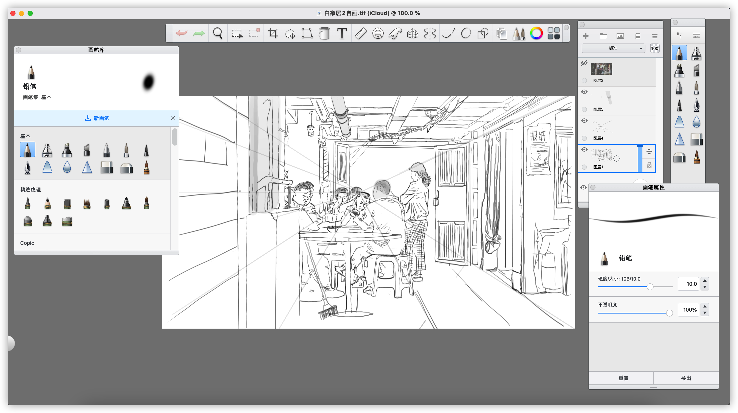

Design and draw the scene using AutoDesk Sketchbook

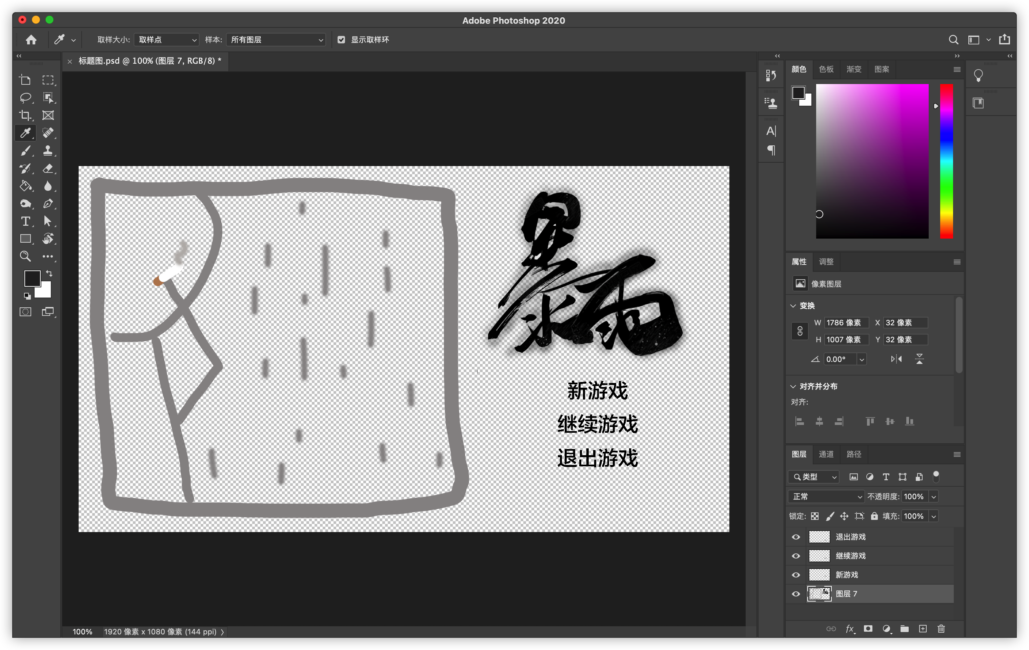

Use Adobe Photoshop to design, paint, and modify the UI

The development tools that will be used in the development of the project are:

1. Visual Studio for Mac (version 8.10.20)

2. Unity Hub (Version 3.3.0-c8)

3. Unity 2022.2.1 11f1c1

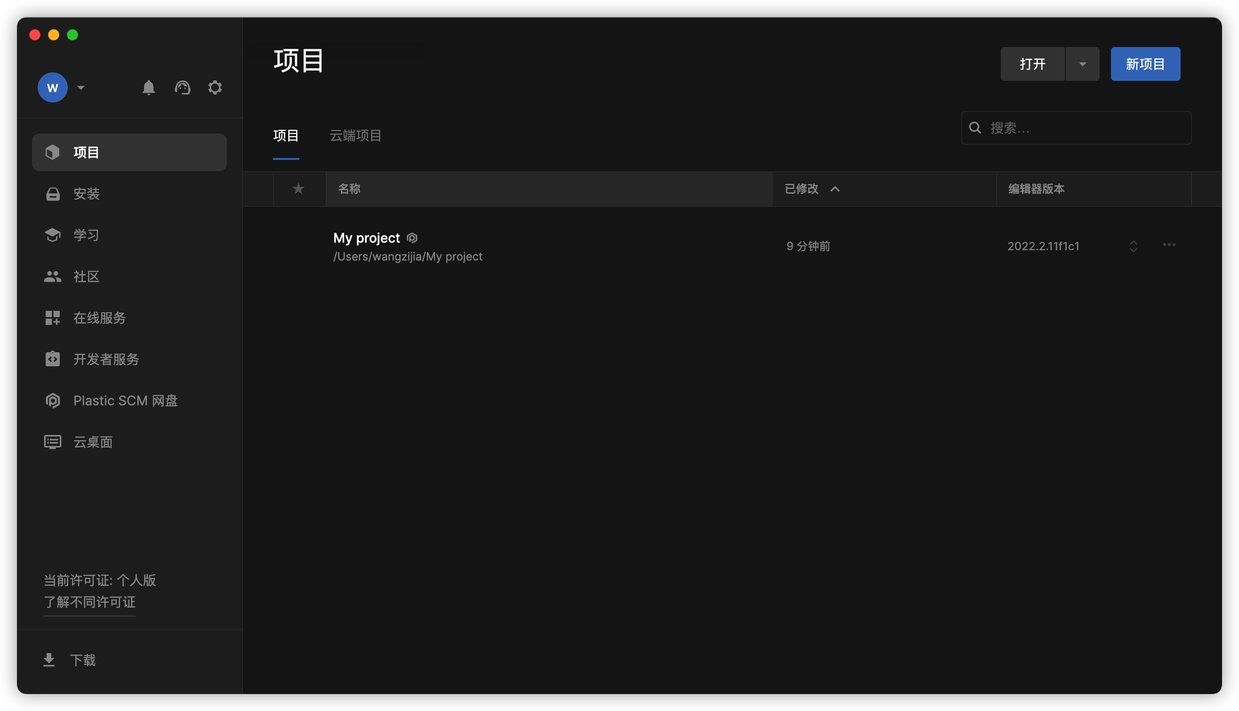

Create an existing Unity project using Unity Hub management

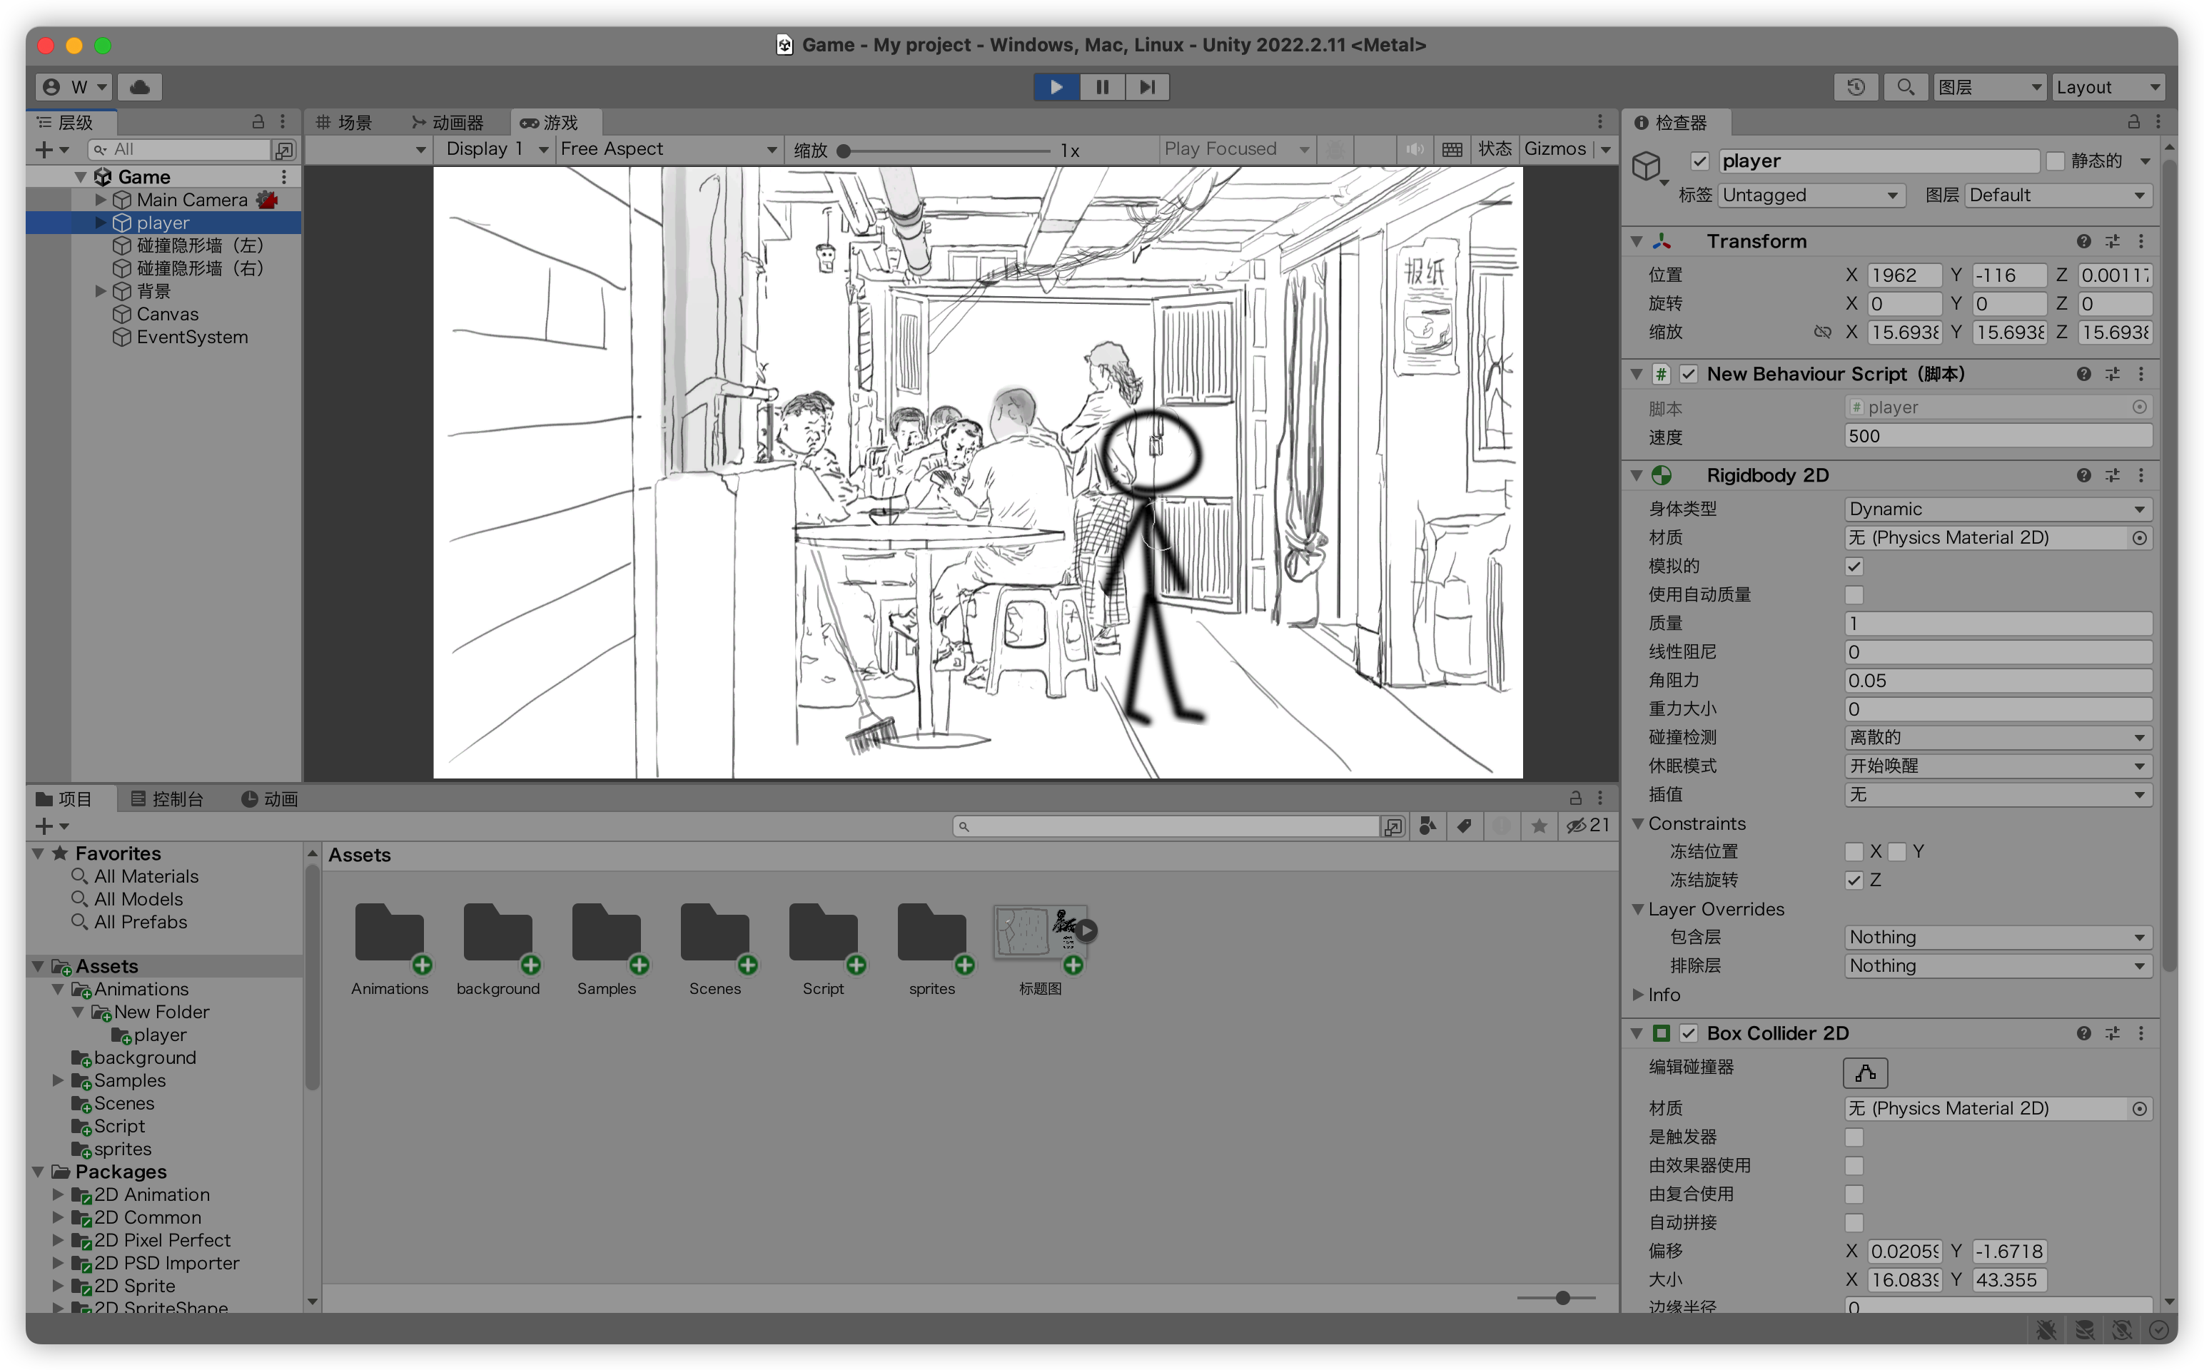

Create, design, and edit game projects in Unity

Management software to be used for project management:

PingCode Intelligent research and development management tool (version 4.119.0)

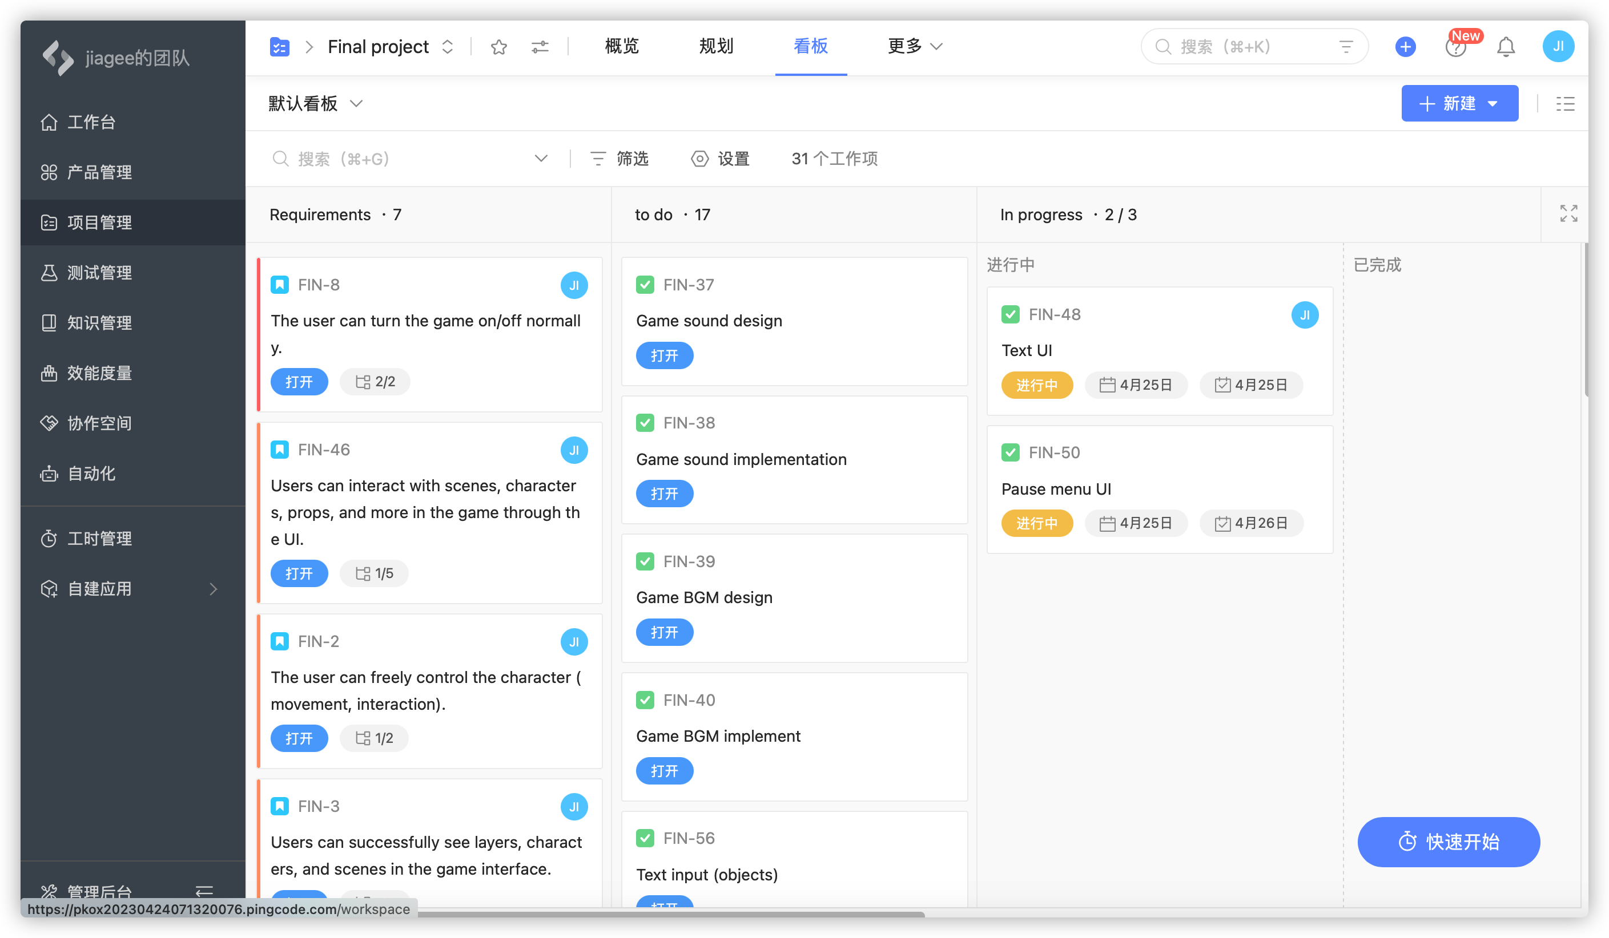

Use PingCode to manage the entire project progress

### **Testing and Evaluation**

Acceptance test:

Test whether the game can run normally, whether the menu and other UI interface can load normally, whether the game can exit normally.

These include: Installation (upgrade), startup and shutdown, functional test (positive example, important algorithm, boundary, timing, negative example, error handling), performance test (normal load, capacity change), stress test (critical load, capacity change), configuration test, platform test, security test, recovery test (in case of power failure, hardware failure or network failure, etc., Whether the system can run normally), reliability test, etc.

The following work will be done before the actual user acceptance test (which can be selectively adopted or added according to the actual situation) :

● Software development has been completed and all known software defects have been resolved.

● The acceptance test plan has been reviewed and approved, and is under document control.

● The review of the software requirements specification has been completed.

● Review of summary design, detailed design has been completed.

● Code reviews for all key modules have been completed.

● Reviews of unit, integration, and system test plans and reports have been completed.

● All test scripts have been completed, executed at least once, and passed review.

● Use configuration management tools and put the code under configuration control.

● The software problem handling process is in place.

● Acceptance test completion criteria have been developed, reviewed and approved.

Functional test:

Test whether the archive reading function can run normally. After entering the game, the test user starts a new game, establishes the game progress and saves the game. After exiting the game, the game is run again to check whether the save is lost. After confirming that it is correct, the file is read to determine whether the function can work normally.

In the acceptance test, also need to pay attention to the document review, before the test should be familiar with the structure of the game program, through the file structure directory to understand whether the file is able to execute properly. Before the game is delivered to users, it is important to ensure that the project itself has tested all aspects of the software adequately. In the end, the development team will invite several test players to play the game, evaluate it, and check whether the documents provided by the development team are complete.

## **Project Version Management**

In this section, students must describe how they have used resources such as Baidu drive, Gitee, etc., to manage their project source codes. The link to the full project source should be provided.

# **Results**

Here students are to provide detailed descriptions and documentation of results and testing. Critical evaluation and discussion of results, issues encountered constraints, limitations, and originality.

The subsection layouts of this section mostly depends on the type of project that the student is carrying out. Students can introduce subsections that will help the readability of their work.

For instance, students doing software development-based projects should provide the detailed use of their software in this chapter. Screenshots (images) of their graphical user interfaces can be depicted in this chapter. Other relevant details about the testing and evaluation of their software can be stated here as well.

Also, students doing research-oriented projects (machine learning & deep learning projects) should state the results of their model training, validation and testing. Use appropriate graphs and figures to illustrate your results. Results from case studies and ablation study of hyper-parameters should be stated here. In a situation where a machine learning-based project was deployed as a web or mobile application, students are to provide details of functionality tests.

# **Professional Issues**

## **Project Management**

### **Activities**

State the complete tasks for each objective. The details here can be presented by a table.

### **Schedule**

In this section, you can use a Gantt chart or other charts to show the activities and their deadlines. Highlight all completed tasks in the project schedule chart.

### **Project Data Management**

In this section, students must describe how they have used resources such as Baidu drive, Gitee, etc., to manage project logs, reports, literature, etc.

### **Project Deliverables**

In this section, briefly list all the documents and project resources that have been submitted for assessment. Example: Project proposal, progress report, final report, project code/ software, poster presentation file, etc.

## **Risk Analysis**

Risk analysis as informed by the current project progress; Resolved risks and the success of the mitigation strategy; Changes to the project plan as a result of risks; Future risks.

### **Risk analysis of game fun**

This risk is very important because it can lead to a design failure. The purpose of playing a game is to have fun. If there is no fun, players will soon lose interest in the game, which is undoubtedly devastating to the game design. The solution to this risk is as follows: Let the developers design a simplified version of the game (demo) for the players to release the trial version of the game in advance, so that the players feel the interest of the game, in the long term development of the game, this method can let the developers, designers find out the problems in the game mechanism, let them have the opportunity to optimize and modify the game, to bring better game experience to the users.

### **Game engine risk analysis**

Here's a first question: What if the game engine can't support all the graphics and animations? This is also a common problem in the development part of game design, and if it is serious, the player will not be able to play the game properly. The solution to this problem is to prototype the game as early as possible. The prototype should show as much as possible what the game will look like on the screen at each stage, and also test whether the game engine can be used properly in the game, if not, make the change as early as possible.

### **Risk Analysis of game level Design**

Level design is undoubtedly the most important part of this project to develop a game based on story experience. However, level design does not require designers to design as many elements as possible to reduce the aesthetic fatigue of players, which will make the development cost and time of the project reach a very terrible amount. If the time consumed exceeds the expected value, the game design needs to be changed immediately. Reduce elements, can also use reuse thinking to solve the problem of large design engineering.

### **Risk Analysis of game character design**

Another question to consider in game development and design is: Will the player like the characters, story, setting, and map the design team has created? Such a problem obviously cannot be solved by prototyping, because in any case testing is judged by the developer's own standards and cannot get the design tendency that the general public can accept. The solution is to let the artists first design the first draft of the game's plot, characters, scenes, and other important things that need to be paid attention to. After getting the first draft, they can show it to the target users and record their comments and feelings on the work.

### **Network security risk analysis**

The game is based on the Internet, leaving the Internet game will be a lot of color, the network game brings us not only fun, but also with a lot of hidden dangers. The open nature of the Internet leads to Internet failures caused by network infrastructure failures, software vulnerabilities, power supply, natural disasters, and even malicious attacks by network hackers, which interfere with the normal operation and information security of the Internet. As a result of the above reasons, the property loss of game players will be reduced, the experience of game players will be reduced, and the reputation of developers will be affected, which will have a negative impact on game products. (3) Risk of infringement of privacy

Game companies are subject to government regulations on privacy and other legal obligations in the processing, storage and use of personal data and other data, and actual or perceived failure to comply with such obligations could harm the business of game companies.

### **Risk analysis of infringement of others' intellectual property rights**

In the process of independent research and development of online game products, game developers may face the risk of litigation for infringement of others' intellectual property rights by a third party due to insufficient internal control of the team, mistakes in the investigation process, or deviation of team members' understanding of intellectual property rights. If the game product is further identified by the competent authority as infringing the intellectual property rights of others, the developer may bear the corresponding infringement liability, and the original product must be modified or adjusted, and the game product may even be removed from the shelves, thus adversely affecting business performance and other aspects.

## **Professional Issues**

Identification and discussion of relevant legal, social, ethical, and environmental issues in the context of the project. Refer to professional codes of conduct, e.g. BCS, ACM.

# **Conclusion**

Summary of what was achieved and potential future work.

# **References**

1. Lim Eng Lye and Mas Idayu Binti Md Sabri, "Learning history through computer game authoring," 2013 8th International Conference on Computer Science & Education, 2013, pp. 746-750, doi: 10.1109/ICCSE.2013.6554007.

2. S. A. E. Campos, B. A. M. Morales and Á. A. V. Núñez, "Open-Source Game Engine & Framework for 2D Game Development," 2022 IEEE Engineering International Research Conference (EIRCON), 2022, pp. 1-4, doi: 10.1109/EIRCON56026.2022.9934816.

3. N. F. M. Nusran and N. A. M. Zin, "Popularizing folk stories among young generation through mobile game approach," 5th International Conference on Computer Sciences and Convergence Information Technology, 2010, pp. 244-248, doi: 10.1109/ICCIT.2010.5711065.

* The layout above is a suggestion of how to present your Final Project Report. Whenever appropriate, introduce sections that will help the readability of your work.
* The Length of the final report should be **8000 – 10000 words**.
* All sections and subsections should be numbered for cross-referencing purposes.
* Regarding citations and references, students must adhere to the University guidelines or IEEE referencing style. **Students doing software development-based projects can cite related websites, web applications, developer documentation, etc. They can cite related articles to their projects, but it is not required. Students doing research-oriented projects should focus on citing research articles. They can also cite appropriate websites whenever necessary. Students are advised to use appropriate reference management software such as Mendeley Reference Manager or Zotero to ensure the correctness of all references.**

## **Formatting Requirements**

Your written report must be presented in the following format:

* All main sections/chapters should begin on a new page. The Declaration page, Tables of Contents pages, Acknowledgment, Abstract, Abbreviation, Glossary, Project Chapters (Chapters 1 to 6), and Appendices should all start on a new page.
* It must be word-processed in 11-point Arial font.
* It must be black text on a white or ivory background
* All pages must be numbered. Follow the appropriate page numbering format specified in the template.
* Margins must be as follows: Top: 1 inch, Bottom: 1 inch (2.5 cm), Left: 1.25 inches, Right:
* 1.25 inches (3.2 cm)
* Use a line spacing of 1.5
* Numbers and captions to figures and tables should be at the bottom of the figure or table. If the figure or table is mounted sideways into the report, then its bottom is on the right-hand side of the report. **All tables and figures must be labeled**.
* Normally, the report should not contain more than 80 tables/figures.

## **Written Presentation**

* The final project report must have a concise written presentation and referencing style.
* It should also have a clear & logical presentation.

**NOTE:**

1. **All the text in red colour are basic guidelines and must be DELETED after using this guide.**
2. **Finally, update the “Table of Contents” appropriately to display the correct section titles and corresponding page numbers.**

# **Appendices**

This section can have the essential information/data that are necessary to be included within the report but would disrupt the flow of the main argument. This section is not marked. Examples include links to data and software repositories, questionnaires, raw survey results, and wireframes.